Overview of Spring Database Integration
Objectives
Key objectives of this chapter:
- DAO Support in Spring
- Defining DataSources
- Database exception handling
- Various data access technologies supported by Spring

  - DAO Design Pattern
- A data access object (DAO) is a pattern for separating data access logic from the rest of your application.
- DAOs use underlying data access technologies such as Java Database Connectivity (JDBC) or an Object-Relational Mapping (ORM) framework like Java Persistence API (JPA).
- The other objects in your application remain unaware of the specific technology to access a database, or even what kind of database is used.
- Isolating your DB access logic make it
  - easy to switch from one technology to another
  - easy to test the rest of your application without a database.
- DAO objects are sometimes known as “repository” objects.

  - DAO Support in Spring
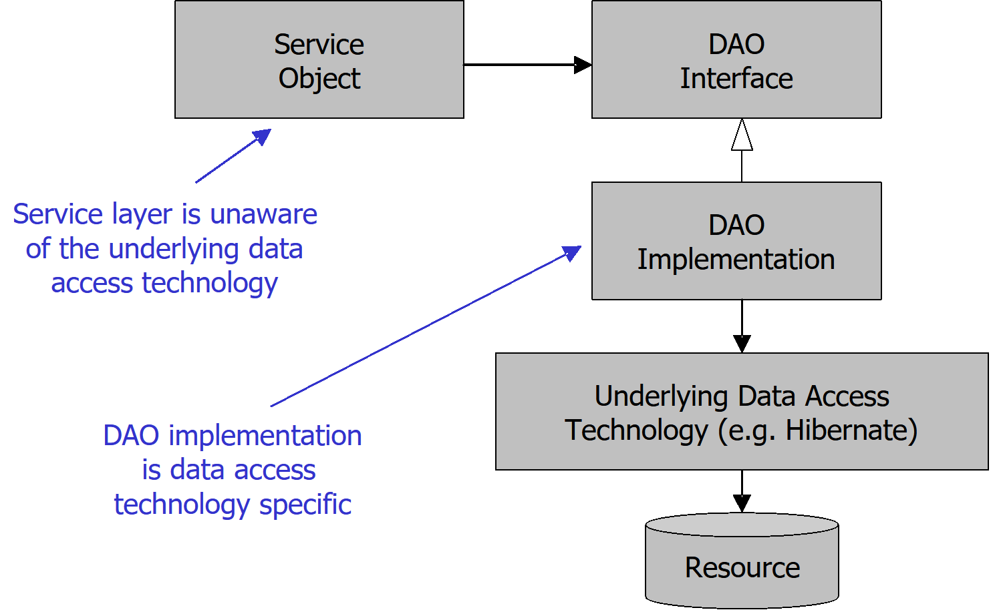
DAO Support in Spring
Spring promotes coding to interfaces and the area of DAOs is no exception. By coding service layers to DAO interfaces, you gain at least two advantages. First, the code is easier to test. Mock DAO implementations can more easily be swapped in during testing of service layers allowing you to fully test a service object without the need for the real DAO implementation and all of its dependencies.
Second, using an interface allows you the flexibility of swapping in a different DAO implementation at deployment time. For example, if you choose to change from JDBC to Hibernate as your data access technology, your service layers are oblivious to this fact and should not need to change.

  - Spring Data Access Support
- The Spring framework offers built-in support for any relational database via its JDBC and ORM modules.
- The separate Spring Data project offers high-productivity support for both relational and non-relational databases
  - Over 20 different database technologies supported in Spring Data, including MongoDB, Redis, Cassandra, etc.

  - Spring JDBC Support
- The Spring framework provides supporting classes for simplifying use of the JDBC API.
  - The JDBC API is considered a low-level API, requiring verbose and redundant coding with tedious exception handling.
  - Spring provides the JdbcTemplate and JdbcClient to raise productivity.
- The Spring framework provides support for DataSource access
  - The DataSource is a component of JDBC used for managing connections to relational databases. Spring does not replace it.
  - A DataSource can be defined as a @Bean
  - Different DataSources can be defined using different @Profiles
  - DataSource properties can be set using Spring’s Environment abstraction and @Value annotations.
  - The EmbeddedDatabaseBuilder can be used to build embedded (in-memory) databases (H2, HSQLDB, Derby) - useful in testing.

  - Defining DataSource Beans
- The Spring DataSourceBuilder can easily create a DataSource bean:

@Bean
public DataSource dataSource(
@Value("${db.driverClassName}") String driver,
@Value("${db.url}") String url,
@Value("${db.username}") String username,
@Value("${db.password}") String password) {
return DataSourceBuilder.create()
.driverClassName(driver)
.url(url)
.username(username)
.password(password)
.build();
}

  - The driver class name is be specific to the database, such as:
    - com.mysql.cj.jdbc.Driver - MySQL
    - org.postgresql.Driver - Postgres
    - oracle.jdbc.driver.OracleDriver - Oracle
  - The URL is the location of the database, such as "jdbc:mysql://localhost:3306/mydatabase".

  - Connection Pooling
- Java/Spring applications often optimize database connections by use of a third-party connection pool such as HikariCP, Apache Commons DBCP or Tomcat JDBC pool.
- To use: provide the implementation (JAR) on the classpath, and set the type():
@Bean
public DataSource dataSource(
@Value("${db.url}") String url,
@Value("${db.username}") String username,
@Value("${db.password}") String password) {
return DataSourceBuilder.create()
.type(HikariDataSource.class)
.url(url)
.username(username)
.password(password)
.build();
}

  - Embedded Databases
- For testing, Spring can provide an embedded/in-memory database using the EmbeddedDatabaseBuilder:
@Bean
public DataSource dataSource() {
return new EmbeddedDatabaseBuilder()
.setType(EmbeddedDatabaseType.H2)
.addScript("classpath:schema.sql")
.addScript("classpath:data.sql")
.build();
}
  - addScript() defines the SQL scripts to execute as soon as the database is ready.

  - Selecting a DataSource using @Profile
- It is possible to define different DataSource beans for local development, test, and production. Use @Profile to select:
@Bean("dataSource")
@Profile("local")
public DataSource localDataSource() {
return new EmbeddedDatabaseBuilder()
...
}

@Bean("dataSource")
@Profile("production")
public DataSource productionDataSource() {
return DataSourceBuilder.create()
…
}

  - Spring ORM Support
- ORM frameworks provide a higher-level abstraction to working with relational databases.
- Spring supports ORM frameworks such as Hibernate, MyBatis, JOOQ, as well as any JPA implementation
  - JPA implementations include Hibernate, OpenJPA, EclipseLink, and DataNucleus.
  - Hibernate is both a stand-alone ORM as well as a JPA implementation.
- An application would typically use only one of these frameworks
- Use of the JPA is recommended since it provides a standardized API.

  - DataAccessException
- The Spring framework decouples your application from data access details such as technology-specific exceptions
  - E.g. SQLException from JDBC API, and HibernateException
  - These are often “checked” exceptions; enforced at compile time.
- Instead, Spring provides the DataAccessException and a hierarchy of subclasses.
  - Root cause is still available using getCause()
  - Key benefit: calling objects are decoupled from lower level technologies
  - sdf
- DataAccessException is a RuntimeException
  - RuntimeException are "unchecked"; they are not checked at compile-time.
  - This allows developers the freedom as to when / where to best handle these exceptions.
  - Typically there is little to be done besides logging.

  - DataAccessException
- Spring provides a hierarchy of DataAccessException subclasses representing different types of exceptions
  - E.g. DataRetrievalFailureException – Data could not be retrieved.
  - The names of the exceptions are self-descriptive.
- Spring converts original technology-specific exceptions to specific subclasses in this hierarchy
  - Spring understands some database specific error codes and ORM specific exceptions
- Spring exceptions are more descriptive
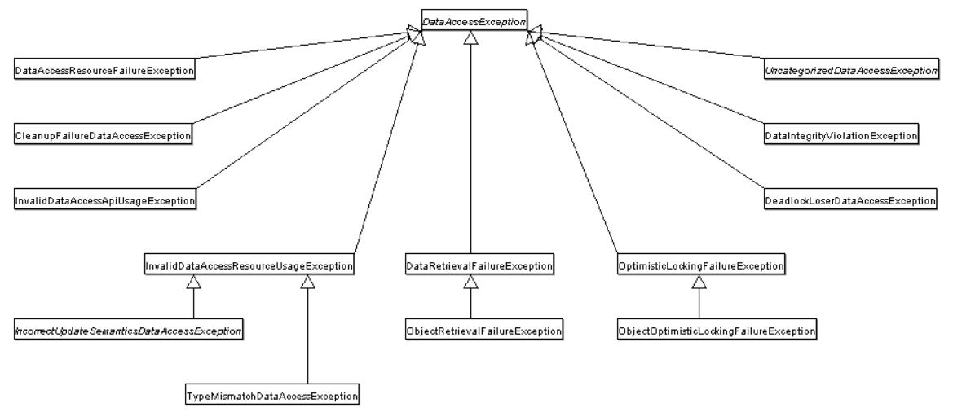

  - @Repository Annotation
- Recall: @Repository is one of Spring’s "stereotype" annotations. It represents a @Component that serves as a DAO/repository.
- Spring automatically translates exceptions thrown from @Repository beans into DataAccessException or a subclass.
  - No other code needed.
@Repository
public class PurchaseDAOJDBCImpl implements PurchaseDAO {

  - Knowledge Check #1
- What is the purpose of connection pooling in a DataSource?

1. A connection pool creates a data caching layer which reduces database reads.
2. A connection pool recycles database connections, resulting in higher performance.
3. A connection pool allows a Spring application to connect to databases implemented in different languages.
4. A connection pool allows a Spring application to connect to multiple databases simultaneously.

  - Knowledge Check #1
- What is the purpose of connection pooling in a DataSource?

1. A connection pool creates a data caching layer which reduces database reads.
2. A connection pool recycles database connections, resulting in higher performance.
3. A connection pool allows a Spring application to connect to databases implemented in different languages.
4. A connection pool allows a Spring application to connect to multiple databases simultaneously.

Connection pools create a cache of database connections which can be reused, but they do not perform any caching on the data read from databases. JDBC drivers can connect to any kind of database which supports the JDBC protocol, regardless of the underlying language. A database connection pool is a pool of connections to a single database.

  - Summary
- Spring supports access to relational database based on JDBC and ORM.
- The DAO pattern makes it easy to switch data access implementations with minimum impact on the rest of an application
- Spring’s DataAccessException provides a generic hierarchy of self-describing, technology-independent Runtime exceptions.
- Spring provides various ways to define DataSource beans
- @Repository enables Spring's DataAccessException translation

